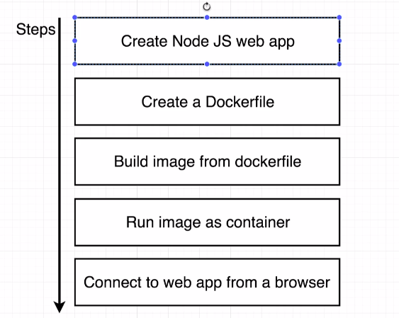

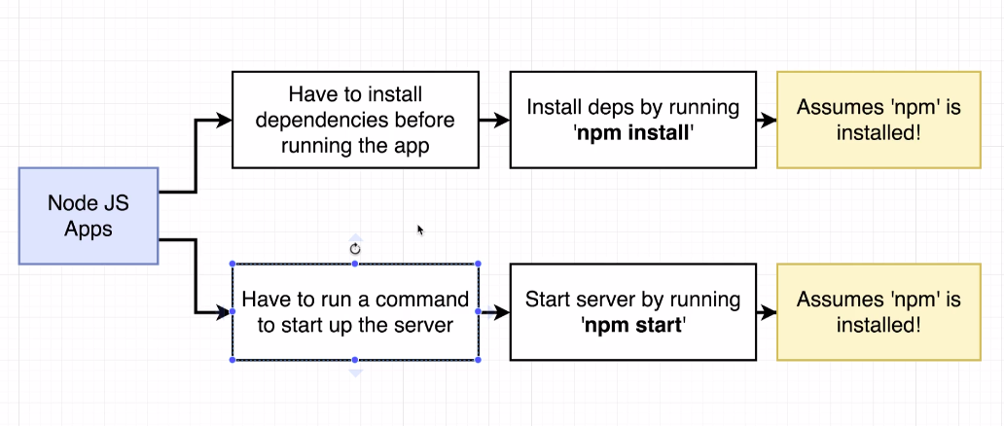

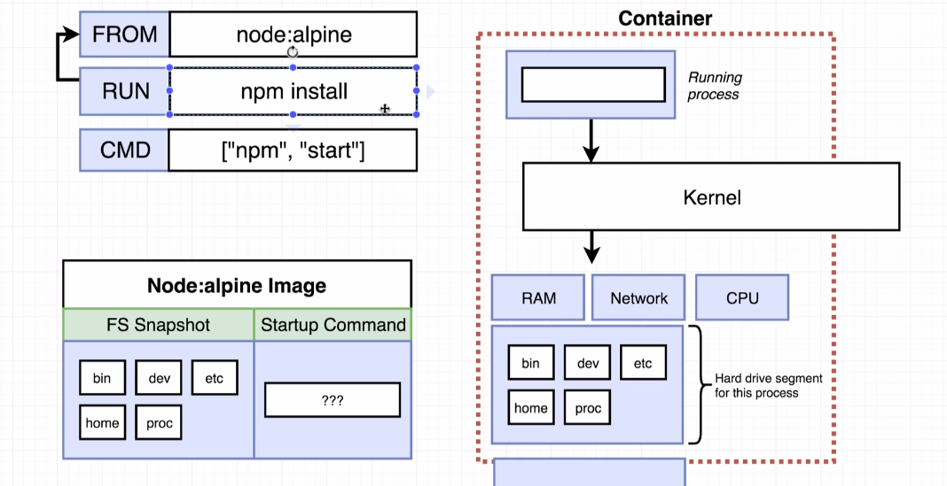

geekarea@geekarea-Inspiron-7559:~/Docker/make project with docker/simpleweb$ docker build -t nodeproject/simpleweb .
Sending build context to Docker daemon 4.096kB
Step 1/4 : FROM node:alpine
---> 3bf5a7d41d77
Step 2/4 : COPY ./ ./
---> Using cache
---> 799bbf36f2e5
Step 3/4 : RUN npm install
---> Using cache
---> 4c5e756b94bc
Step 4/4 : CMD ["npm","start"]
---> Using cache
---> a360f2fd3360
Successfully built a360f2fd3360
Successfully tagged nodeproject/simpleweb:latest
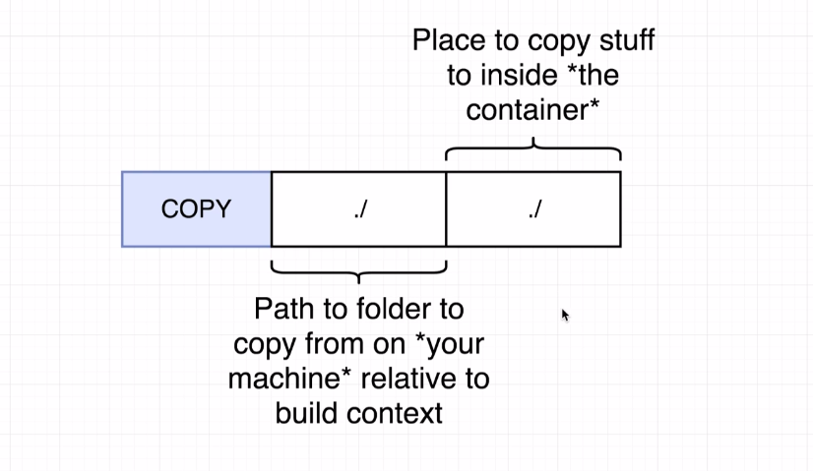

Port Mapping :

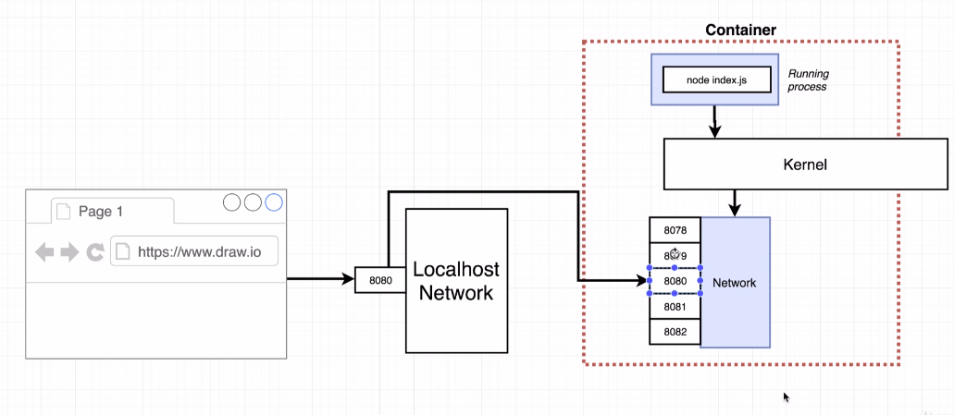

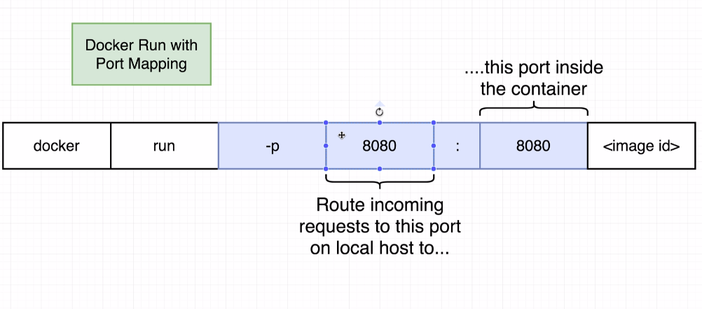

eekarea@geekarea-Inspiron-7559:~/Docker/make project with docker/simpleweb$ docker run -p 8080:8080 nodeproject/simpleweb:latest

> @ start /usr/app
> node index.js

Listening on port 8080

# Add dependencies

